**P6 – Explain the potential legal implications of using and editing graphical image**

**Introduction**

In this report, I will be naming the potential legal implications of using and editing graphical images. This means that if someone used another picture without permission, what would happen to him or her.

**Legislation and guidelines**

**Identifying ownership**

When any user creates a graphical image, logo or anything that they have made; it will belong to them. For any other user to use the graphical image, they would need to seek permission from the owner to use this image anywhere else. An example of a graphical image that could be used once granted permission is the following:

* Logo
* Business name
* Graphical image
* Videos
* Anything that is to another that another person cannot use

This doesn’t only include logos, it could include business names. Any new entrepreneur, he or she need to come up with a name that has not been used in the nation. For example, SAMSUNG logo, if someone else wants to use it, they would need to ask the company owner and they will have to wait until the SAMSUNG owner has granted the person permission.

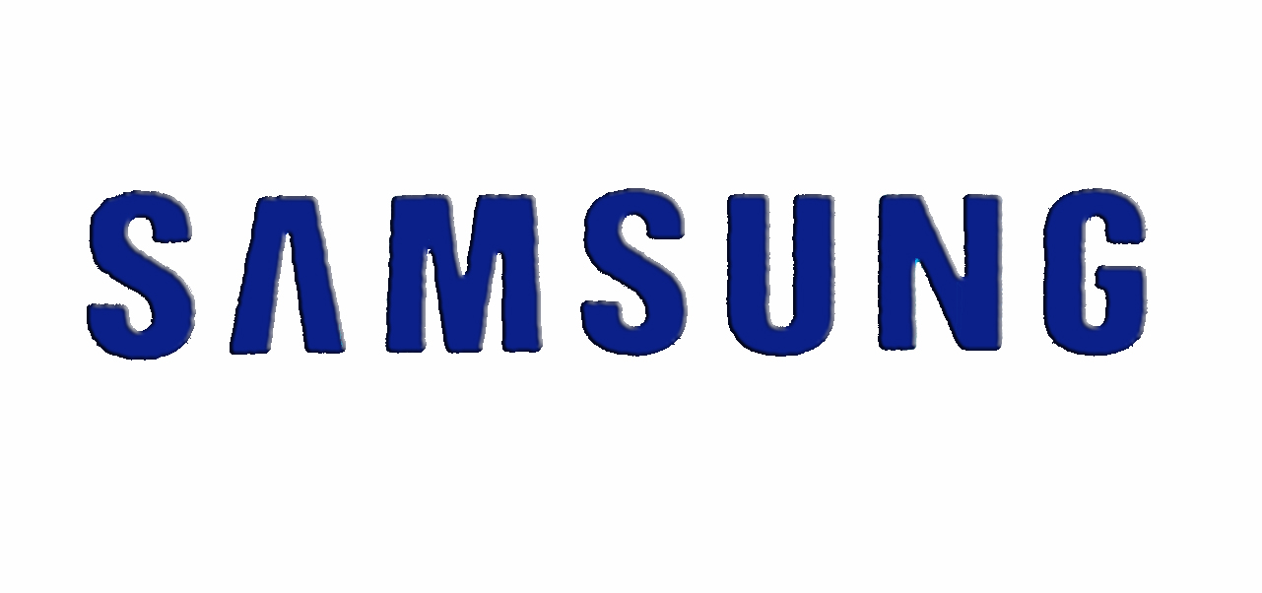

**Copyright**

Copyright is a legal concept enacted by the government that enables businesses or any owner of a graphical image that give the owner rights and policies of how to use the unique work that they have created. It gives a licence so it can let others use it. This is the copyright logo that could be inserted within the unique granted image. This shows that it has been copyrighted. It is not as big as this but it is small. Many people need to recognise it before use.

[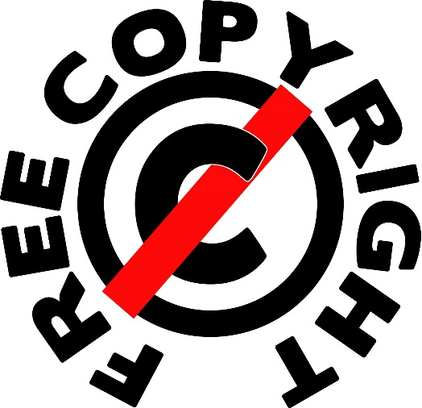](http://images.tentebranda.org/free-copyright-images/free-copyright-images-7/)**Copyright free**

Copyright free, as the name suggest, is has no licence over the use of the image. This means that the graphical image can be used on works for free. The major way the image can be copyright free once its licence is expired. For it to be copyright, it needs to be licenced and continued to be reviewed. Once it has not been licenced, it is copyright free.

**Gaining permissions**

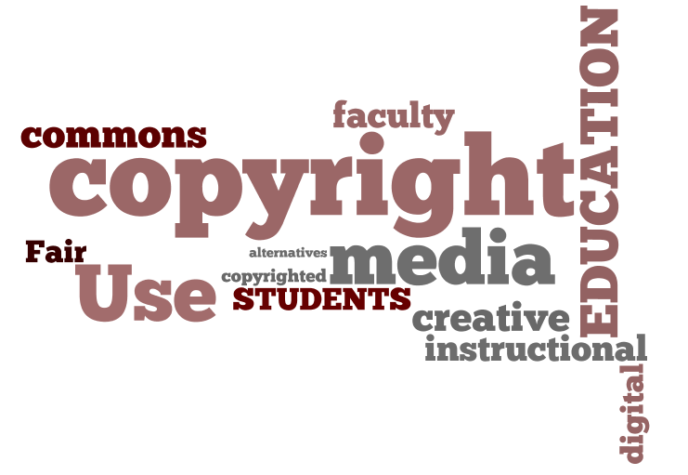Gaining permission is the best way for another user to use the image that the owner has created. The way another user gains permission is to sign and agree a contract with the owner. The contracts includes policies of the image and once it has been agreed, the user can use the image. If they do not sign or ask permission, they would need pay a heavy fine once the user has unauthorised access with the image. The fine could go up to £50,000. The user who wants to use the image could sent the letter and they could ask him in any way or form to use the image.